Forming a committee to choose the best design for the EL-Obour branch of Benha University

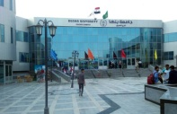
Prof.Dr. Gamal EL-Saeid, the university president issued a decree to form a committee to choose a logo for the EL-Obour branch of Benha University. This committee includes prof.Dr. Marwan Abd EL-Mohsen, prof.Dr. Shaaban Taha Ibrahim, prof.Dr. Abd EL-mommen shams EL-Kornfolly, Eng. Tarek Ali Ibrahim and Eng. Monira Muhammad Habib.

