New Appointments for Deputies at Benha University

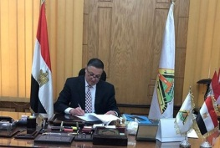
Dr\ Gamal El Saeed, Benha University President has issued several decrees to appoint Dr\Ashraf Tawfiq Shams El Din as the Faculty of Law deputy for Community Service and Environment Affairs. He also appointed Dr\ Essam Hosny Mohammed as the Faculty of Law deputy for Post graduate Studies and Scientific Research. El Saeed also appointed Dr\ Omar El Farouk El Hoseny Abd El Aziz as the head of criminal law department.

