Workshop at Benha University about Egyptian Knowledge Bank

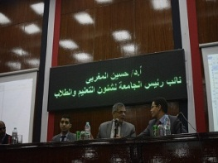
A workshop about how to use the Egyptian Knowledge Bank was held at Benh University under auspices of Dr\ Gamal El Saeed, Benha University President and Prof.Dr Hussein El Maghraby, the University Vice-president for Education and Students' affairs. The Workshop was held in presence of Dr\ Nasser El Gezawy, The Supervisor on Post Graduate Studies and Scientific Research Sector, Faculties' deputies and students. El Maghraby confirmed that the University seeks to spread the culture of using the Egyptian Knowledge Bank as an important source for education, teaching, researchers and students In addition to helping students and researchers to get information easily.

