Benha University participates in the 6th Cairo International Exhibition for Innovation

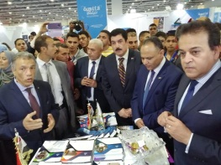
Benha University participates at the 6th Cairo international Exhibition for Innovation under auspices of Prof.Dr.Gamal El Saeed, Benha University President. The Exhibition is organized by Scientific Research and Technology Academy for the 6th year. Dr\ Khalid Abd El Ghaffar, minister of High Education and Scientific Research opened the Exhibition in presence of Dr\ Gamal El Saeed, Benha University President, Dr\ Ragab Mejahed , Faculty of Engineering dean and Dr\ Alaa Abd El Halim , the Governor of El Qalyubia.

