New Appointments at Benha University

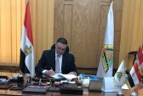
Prof.Dr.Gamal El Saeed, the President of Benha University issued several decisions of appointments as following; Dr\ Ibrahim Mahammed Rageh was appointed as the head of pathology department and Dr\Mohammed Saeed, the professor at civil Engineering department was appointed as advisor to the University President for engineering affairs

