Increasing the levels of emergency in Benha University hospitals for the spring holidays

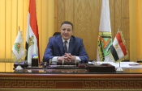
Prof.Dr. Gamal El-Saied, the university president decides to increase the levels of emergency in Benha University hospitals for the spring holidays. He also decides to cancels all days-off until the end of the occasion while stressing that the University hospitals should be well-ready to receive any patients at any times.

