President of Benha University in a meeting with students of the Faculty of Applied Arts.

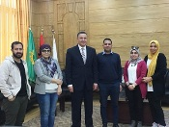
Under the leadership of Prof. Dr. Gamal El-Said, President of the University, under the guidance of Prof. Dr. Abdel-Mo'men Shams El-Qarnafili, Dean of the Faculty of Applied Arts, to implement the best educational methods to connect students to the labor market, a group of students of the third division of the department of advertising, printing and publishing in the college held a photo interview with Prof. Dr. Jamal Al-Said, President of Banha University.

