EL-Magraby welcomes the decree issued by the Cabinet to set up the faculty of medicine at Benha University

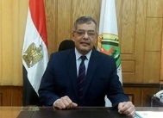
prof.Dr .Hussien Magraby, the university president welcomes the decree issued by the Cabinet to set up the faculty of medicine at Benha University.

