The coronation of Benha University’s stduents’ union in a big ceremony

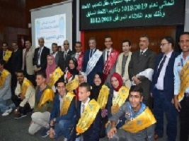
Benha University holds a big ceremony on the occasion of the coronation of the new university’s students’ union in the presence of prof.Dr. Hussien Magraby, the acting university president, the faculties’ deans, the deputies and prof.Dr. Khalid Eswai, the coordinator of the students’ activities

