Announcing the results of the stduents’ union elections in Benha University

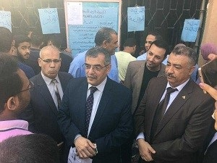
Prof.Dr. Hussien Magraby, the acting university president announces the results of the stduents’ union elections in Benha University. the university president is accompanied by prof.Dr. Hesham Abu EL-Enin, prof.Dr .Eid Hemida, prof.Dr. Khalid Esawi and prof.Dr. Moshbeh El-Kehily.

