Tomorrow is the introductory day of the new programs at Benha University’s faculties.

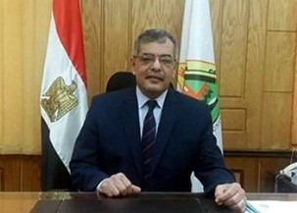
Under the presidency of prof.Dr. Hussien EL-Magraby, the acting president of Benha University, the introductory day of Benha University’s new programs will be held at the conference hall in the faculty of commerce.

