“We seek to establish a new Benha university specialized hospital to serve the inhabitants of Qulubia governorate” says Abd EL-Halim

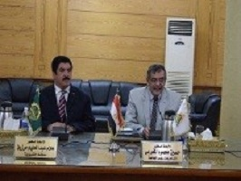
Prof.Dr. Alaa Abd EL-Halim stresses that the governorate seeks to cooperate with Benha University to establish a new specialized hospital to serve the inhabitants of Qulubia governorate and provide a quality healthcare to all of them.

