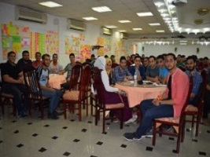
A workshop of enterpreneurship of benha University's students in cooperation with the ministry ofcommunication

The workshop that is organzied by the technological center and enterpreneurship in the ministry of information and communication has been finished today. There are many students who are trained on how to start up a small project and enterpreneurship according to what has been said by prof.Dr. EL-Sayed EL-Kady, the university president.

