El-Magraby participates in receiving the Benha University’ students at the first day of the new term

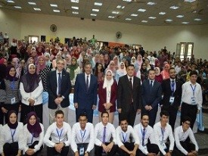
Prof.Dr. Hussien EL-Magraby, the university president is keen on participating in the reception of the Benha University students and the composition of the national anthem. The university president goes on a tour in the lectures halls, labs to make sure that the everything is up and running.

