“EL-Kady meets with the Benha university students who were sent for scholarships in China

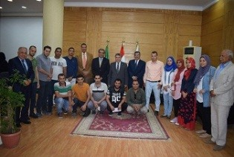
Prof.Dr. EL-Sayed EL-Kady, the university president meets with 14 students of the university who were sent for MA and PhD scholarships in China. EL-Kady stresses that Benha University’s students should be sent for scholarships to help the Egyptian community to solve its problems.

