The educational affairs in Benha University announces the results of the exams

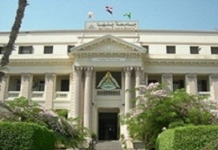
Prof.Dr. Hussien Magraby, the vice University president of the student and educational affairs stresses that the results of exams should be announced perfectly according to the deadline of the University council under the auspices of prof.Dr. EL-Sayed EL-Kady.

