A statement from Benha University

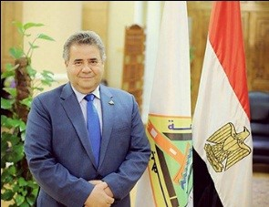
In this historical day in which the president Abdel-Fattah El-Sisi takes the constitutional oath in front of people's assembly as the Egyptian president for a second term to continue his 4- year journey of development and progress. Benha University cordially stands by the side of the president to continue his journey of development and progress. Long live Egypt!

