El-kady decides to declare the emergency status in Benha University hospitals

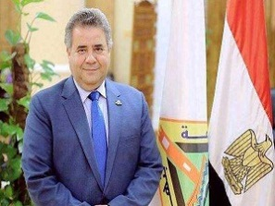
Prof.Dr. EL-Sayed EL-Kady, the University president decides to declare the emergency status in Benha University hospitals during the feast of EL-Fitr in addition to providing the hospitals with the necessary medications

