“Changing from education to learning is a must” says prof.Dr. Muhammad EL-Nashar

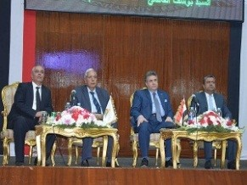
Prof.Dr. Muhammad E-Nashar, the former minister of higher education asserts that the philosophy of education in the Egyptian Universities should be changed form education into learning and we have to use the modern technology. This statement concurs with the forum entitled “toward an electronic University” which was organized by the university and the information and decision making center in the Egyptian cabinet. The forum was attended by Eng/ Hossam EL-Gamal, the head of the information and decision making center in the Egyptian cabinet, prof.Dr. Kamal Shawarim, the general secretary of the presidential specialized councils, prof.Dr. Muhammad El-Nashar, the former minister of higher education, prof.Dr. Mervat El-Deeb, the coordinator of the Egypt’s scientists council, prof.Dr. Gamal Ismail, the vice president of the community service and environment development, the faculties’ members and the students.

