“We are proud of the armed forces and the police” says prof.Dr. Kamal Shawarim

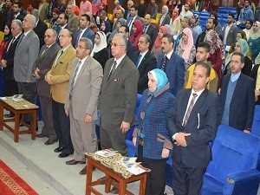
Prof.Dr. Kamal Shawarim, the general secretary of the presidential specialized councils asserts that the students should participant in politics as they are the partners in building the homeland future. Shawarim hails the efforts exerted by the armed forces and the police in their war against terrorism in order to achieve the stability for all of us. This statement concurs with the forum entitled “toward an electronic University” which was organized by the university and the information and decision making center in the Egyptian cabinet. The forum was attended by Eng/ Hossam EL-Gamal, the head of the information and decision making center in the Egyptian cabinet, prof.Dr. Kamal Shawarim, the general secretary of the presidential specialized councils, prof.Dr. Muhammad El-Nashar, the former minister of higher education, prof.Dr. Mervat El-Deeb, the coordinator of the Egypt’s scientists council, prof.Dr. Gamal Ismail, the vice president of the community service and environment development, the faculties’ members and the students.

