“Benha University fights corruption to achieve the accomplishments” says EL-Kady in the forum entitled “toward an electronic University”

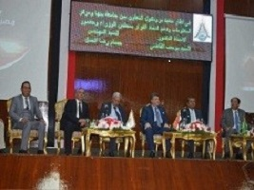
Prof.Dr. EL-Sayed EL-Kady, the University president asserts that Egypt witnesses a great boom in the different aspects of life and we witness a new accomplishment every day that is added to the list of the accomplishments of the last years. EL-kady says that we work hard to cope up with these accomplishments by getting the employees and the students feel the accomplishments done by the University. This statement concurs with the forum entitled “toward an electronic University” which was organized by the university and the information and decision making center in the Egyptian cabinet. The forum was attended by Eng/ Hossam EL-Gamal, the head of the information and decision making center in the Egyptian cabinet, prof.Dr. Kamal Shawarim, the general secretary of the presidential specialized councils, prof.Dr. Muhammad El-Nashar, the former minister of higher education, prof.Dr. Mervat El-Deeb, the coordinator of the Egypt’s scientists council, prof.Dr. Gamal Ismail, the vice president of the community service and environment development, the faculties’ members and the students..

