Honoring the students of Benha university who wins the award of the imitating the Egyptian Cabinet

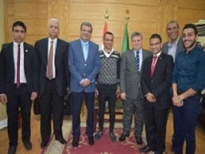
Prof.Dr. EL-Sayed EL-Kady, the university president honors the student/ Khalid Aly and the student/Ahmed Muhammad who achieves a great win in imitating the Egyptian cabinet prototype that was held in the American University in Cairo. The honoring event is held in the presence of prof.Dr. Gamal Ismail and prof.Dr. Hesham Abu EL-Enin

