An emergency meeting of Benha University’s council
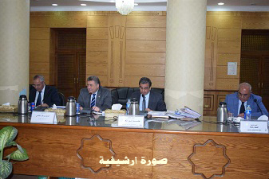
There is an emergency meeting of Benha University’s council that will be presided over by prof.Dr. EL-Sayed EL-Kady, the university’s president to discuss several topics including the increasing the awareness of the students to participate in the upcoming presidential elections and letting them know that their votes affect the future of Egypt.

