EL-Kady goes on many tours in the university’s hospital
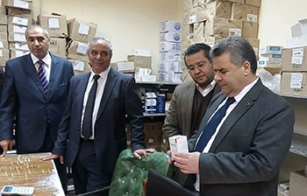
Prof.Dr. EL-Sayed EL-kady, the university’s president goes on sudden tours of the university’s hospitals as he visits the external clinics and the drugs warehouses. He was accompanied by prof.Dr. Gamal Ismail, the vice president of community service and environment development, prof.Dr. Ibrahim Ragah, the head of the university’s hospitals, prof.Dr. Amr EL-Dakahney, the head of the external clinics in the hospitals and Mr. Wahid Khalawy, the university’s assistant secretary of the administrative affairs. The university’s president urges to develop the pharmacies in the university.

