The technical committee of the university’s elevator decides to issue a stop order for five elevators in the university

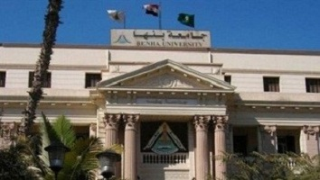
The technical committee, which was formed by prof.Dr. EL-Sayed EL-kady on Tuesday evening after the elevator incident, issues a stop order for five elevators in the university. This committee is headed by prof.Dr. Gamal Ismail, the vice president of community service and environment development.

