Benha University moves forward in the international ranking regarding Google scholar citation according webometrics ranking

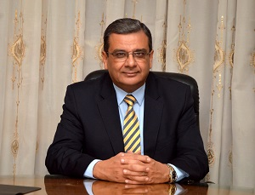
Prof.Dr. Hesham Abu EL-Enin says that Benha University obtains the 8th position according to the Webometrics ranking regarding Google scholar citation in January 2018. Congratulations!

