Benha University enlightens the darkness in EL-Qulubia

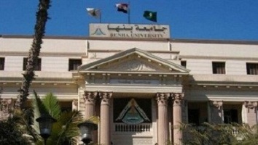
Mr. Ahmed Abd EL-Karim, the journalist in “El-Akbar” newspaper wrote an article about Benha University on Facebook entitled “Benha University enlightens the darkness in EL-Qulubia “to heap the praise on the Benha University’s achievements on the national and local apparatuses.

