19835 students are having their first term exams in the faculty of commerce
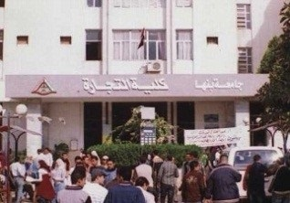
There are 19835 students who are having their exams including4302 students who are having their open learning exams, 15105 students who are having their under-graduate students and 428 newcomers. Prof.Dr. Eid Hemida, the dean of the faculty of commerce says that the exams are strictly up and running.

