“We seek to direct our attention to Africa in response of the president’s orders” EL-kady says in Benha University’s council
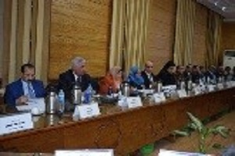
Prof.Dr. EL-Sayed EL-Kady, the University president receives a letter of gratitude from Prof.Dr. Sido Hasan, the vice president of Frontier University in Somalia in which he expresses his happiness because Benha University offers five free scholarships to the students in Somalia in the frame of the Egyptian‘s attention to Africa. El-kady says, in the University’s council, that Benha University offers 100 scholarships to the students in southern Sudan and the University gets in touch with the ministries of foreign affairs and the higher education to start carrying out the decree of the University’s council. He adds that Benha University seeks to direct its attention to Africa in response of the president’s orders.

