A forum about the healthcare insurance law to be held in Benha University
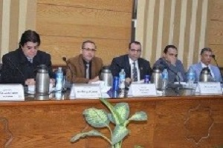
Benha University organizes in cooperation with the ministry of health a forum about the healthcare insurance law that has been endorsed by the people’s assembly lately. This statement is uttered by prof.Dr. EL-Sayed EL-Kady, the university president during the university’s council.

