A big demand from the inhabitant of Kafr-Batta to the Benha University comprehensive convoy
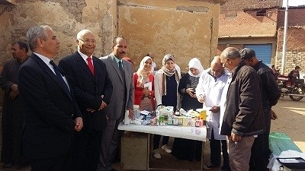
Benha University comprehensive convoy has finished its activities under the auspices of Prof.Dr. EL-Sayed EL-Kady, the University president and prof.Dr. Gamal Ismail, the vice president of the community service and environment development in Kafr-Batta. There are five faculties who participate in the comprehensive convoy, such as the faculty of medicine, the faculty of veterinary medicine, the faculty of education, the faculty of nursing and the faculty of specific education.

