The faculty of science wins the state award of individuals and organizations
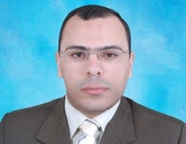
Prof.Dr. Emad Muhammad Muhammad Youssef Masood, the associate professor at the chemistry department in the faculty of science wins the state award of individuals and organizations that is announced by prof.Dr. Khalid Abd EL-Gafer, the minister of higher education and scientific research during his presidency of the board council of the scientific research academy and technology on Tuesday, 28-11-2017 in the presence of the members of the academy and prof.Dr. Mahmoud Sakr, the head of the Academy.

