The sector committee approves to establish a faulty of physical education for the girls in Benha
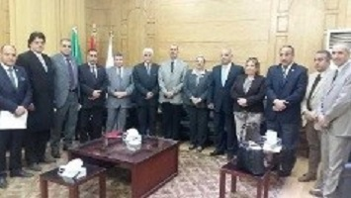
Benha University hosts the physical education sector committee in the supreme council of the universities under the presidency of prof.Dr. Muhammad Sobhy Husseinain, the head of the committee in Benha University. The committee discusses the possibility of establishing a faulty of physical education for the girls in Benha and they approve to establish it. It is important to say that the committee visits the faculty’s building and they were accompanied by prof.Dr. Hussien Dory Abaza, the dean of the faculty of physical education for boys in Benha.

