A committee to be formed to enhance the efficiency of the network of the Benha University

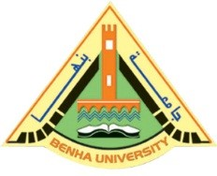
Benha University’s council decides, under the presidency of prof.Dr. EL-Sayed El-kady, the university president to form a committee, under the presidency of prof.Dr. Hesham Abu EL-Enin, the vice president of post-graduate studies and them memberships of several deans and chancellors, to enhance the efficiency of the network of Benha University as soon as possible.

