Benha University discusses the research plan 2017-2022

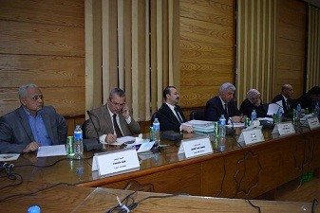
Prof.Dr El-Sayed EL-Kady, the university president urges that there should be cooperation between the research plan of the university, the strategic plan and the quality management center , so that all the plan concur with each other’s and there are no repeated plans that can waste time and effort.

