The Higher education announces the long term Egyptian –German dispatch program- GERLS for 2018
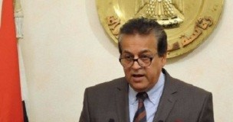
The Higher education announces the long term Egyptian –German dispatch program- GERLS for 2018. Prof.Dr. Khalid Abed EL-Gafer, the minister of higher education and scientific research stresses on the importance of reinforcing the scientific cooperation between Egypt and Germany in the different aspects. He indicates that there should be a fruitful cooperation with the DAAD organization to develop the scientific level of the Egyptian researchers.

