“We seek to reinforce our relationships with Nile Basin countries” says Benha university president
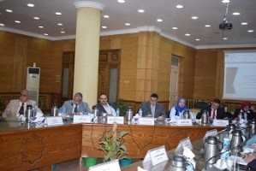
Benha University’s leaders’ council discussed in its meeting yesterday under the presidency of Prof.Dr. EL-Sayed EL-Kady, the letter of cultural relationships sector in the ministry of higher education that is about reinforcing the relationship between Egypt and Nile Basin countries in all aspects, like education and scientific research.

