EL-Kady’s interview on “Cairo” Channel
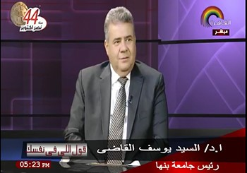
“Cairo” Channel hosts Prof.Dr. EL-Sayed EL-Kady, the university president in a program that is moderated by Mr. Hala Farouk on Tuesday, 30-10-2017 to discuss and the services that Benha University provides to the public.

