EL-Kady is in the Arab university union in UAE
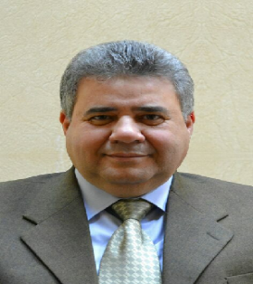
Prof.Dr. EL-Sayed EL-Kady, the university president left, yesterday, Cairo with prof.Dr. Hesham Abu EL-Enin, the vice president of postgraduate studies and prof.Dr. Ghazi Assasa, the chancellor of the international relationships to attend the Arab university union in UAE.

