EL-Kady signs” yes, we can build it” initiative
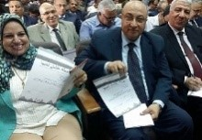
Prof.Dr. EL-Sayed EL-Kady signs “yes, we can build I” initiative to support the president to go for another term. He becomes the first one to sign it to motivate the stduents and the employees to participate in this campaign.

