The Sino-Egyptian conference successfully ends its proceedings
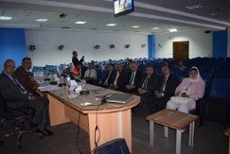
The Sino-Egyptian conference continues its proceedings by holding 14 scientific sessions in different aspects. The Chinese delegation efficiently participates in the proceedings of the second day in the conference. Prof.Dr. El-Sayed EL-Kady expresses his joy for the continuity of the proceeding of the conference in addition to the efficient participation of the Chinese delegation and he also expects that the conference sessions will result in fruitful consequences that will reinforce the Sino-Egyptian relationships.

