“A regular meeting with the Omani students in Benha University” says EL-Kady in his meeting with the Omani cultural attaché in Cairo
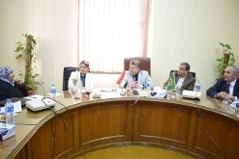
Prof. Dr. El-Sayed EL-Kady, the university president hosts, in his office on Wednesday morning, prof.Dr. Mona bent Mousa EL-zedgally, the Omani cultural attaché in Cairo. This meeting is attended by prof.Dr. Gamal Ismail and prof.Dr. Hesham Abu El-Enin, several faculties’ members and Mr. Wahid Khalawy, the general secretary of the university. This meeting discusses many Omani students related issues who study in Benha University.

