The inauguration of the Benha University exhibition in the Sino-Egyptian conference
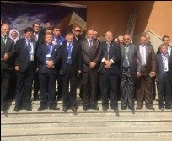
Prof.Dr. El-Sayed EL-Kady, the university president inaugurates, in the presence of the Chinese universities presidents who participate in the Sino-Egyptian conference, the university products exhibition in which five faculties participate and they are as follows: the faculty of engineering, the faculty of agriculture, the faculty of veterinary medicine, the faculty of science, the faculty of specific education and the projects development unit. This exhibition will last for weeks after the conference.

