Cordial congratulation of the New Hijiri year 1439

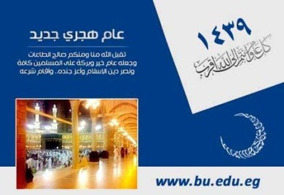
Prof.Dr. El-Sayed EL-Kady, the university president, prof.Dr. Gamal Ismail, the vice president of community service and environment development and prof.Dr. Hesham Abu EL-Enin, the vice president of post-graduate studies and research cordially congratulate the faculties’ members, the employees and the students on the advent of the New Hijiri year 1439.

