Honoring the diligent worker of the faculty of agriculture
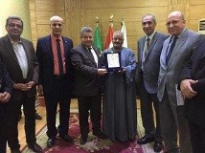
Prof.Dr. EL-Sayed El-Kady, the university president interrupts the university council to honor the diligent worker of the faculty of agriculture Mr.Helal Saad EL-Atroni and he thanks him for keeping up the good work during the EL-Adha Feast vacation. The university president suggests rewarding the worker by giving him a financial award and the university’s council consensually agree on this suggestion. This award was given in the presence of the prof.Dr. Hesham Abu EL-Enin and prof.Dr. Gamal Ismail.

