“Developing education is a main priority for Benha University” says EL-Kady
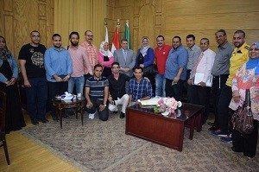
Prof.Dr. EL-Sayed EL-Kady, the university president hosts a number of PhD students in Helwan University to whom the center of languages and translation has arranged a TOFEL course for three days. The students visit the university president to thank him for letting them enroll in this course. The student heaps praise on what is provided to them in the TOFEL course by prof.Dr. Eman Abd EL-Haq, the head of the center and prof.Dr. Reham EL-Gazar, the accredited trainer.

