EL-Kady inaugurates the exhibition of China and the Arab countries in Yinchuan

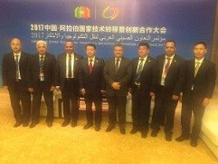
Prof.Dr. EL-Sayed EL-Kady, the university president inaugurates the exhibition of China and the Arab countries in Yinchuan. EL-Kady is keen on participating in this event which host Egypt as a guest of honor for first time. The inauguration is attended by Mr. Howang Wai, the vice minister of science and technology in China and the governor of the Nyanja province and prof.Dr. Mahmoud Sakr, the head of the scientific research academy and the representative of the Egyptian minister of higher education.

