A Two-day bonus to the employees in the university hospitals
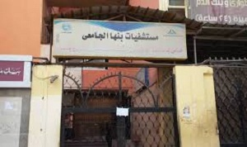
During his three- hour tour in the university hospital, prof.Dr. EL-Sayed EL-Kady, the university president decides to give the employees in the university hospital a two-day bonus in appreciation of their efforts in the feast. The university president heaps praise on the way the employees treat the patients nicely in addition to congratulating them on the occasion of the feast.

