The rate of success of the top ten students at the faculty of informatics is 97.9% and the success rate of computer science is 86%

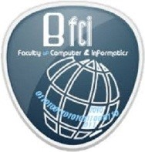
The faculty of informatics and computer science in Benha University announces the results of the academic year and the success rate of the students is 97.9% and the success rate of computer science is 86%.

