The research team at the faculty of veterinary medicine publishes two research papers in two top periodicals

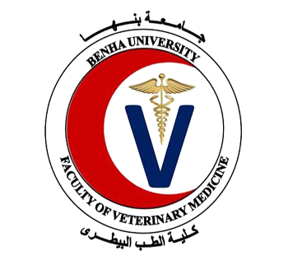
The research team at the faculty of veterinary medicine manages to publish, under the supervision of prof.Dr. Muhammad Ghanem in cooperation with the University of Illinois in USA, two research papers in two top periodicals.

